KRA’s to Strengthen chart in Home Page

Chart shows the list of KRA’s that needs to be strengthened to improve employee performance.

**Version: 1.0**

**Date: 02-Dec-2020**

*All rights reserved. No part of this publication may be reproduced, transcribed, transmitted, stored in a retrieval system or translated into any language, in any form or by any means mechanical, manual, electronic, magnetic, chemical, optical, including photocopying or otherwise without the prior written permission of UPRAiZAL, Inc.*

Contents

Revision History 3

Requirement 4

Implementation Method 4

Code Modifications 4

**File Path** 4

**Purpose** 4

**Modifications** 4

**File Path** 5

**Purpose** 5

**Modifications** 5

**File Path** 6

**Purpose** 6

**Modifications** 6

**File Path** 6

**Purpose** 6

**Modifications** 7

**File Path** 7

**Purpose** 7

**Modifications** 7

List of required Jars & File Paths 7

Use cases (Must for Unit Test) 8

# Revision History

|  |  |  |  |
| --- | --- | --- | --- |
| Version | Author | Date | Description |
| 1.0 | HYD0070BI | 02/Dec/2020 | Initial Version |
| 1.0 | HYD0176SD | 03/Dec/2020 | Initial Version |

**Confidentiality**

The contents of this document are considered confidential and proprietary information of UPRAiZAL, Inc. No part of this document may be reproduced, fully or in part, or divulged to any other party without prior written permission from UPRAiZAL, Inc. All logos of respective owner companies used in this presentation are recognized.

# Requirement

KRA’s to strengthen chart will help employees to know which areas/KRA’s (KRA configured for the logged in Role) he/she needs to improve based on ratings provided by Manager (Both Reviewer 1 and Reviewer 2)

KRA’s to strengthen are nothing but KRA values where rating of manager is lower.

KRA’s to strengthen will be considered for both Reviewers. If only one Reviewer is present, then only one Reviewer will be considered.

So, each KRA’s to strengthen will have count

Higher count of KRA’s to strengthen means that employee needs to improve on that KRA.

Example and explanation provided in requirement document.

On Home page, added this new chart in “My Ratings” chart panel and provided toggle icons to switch between “My Ratings”, and “KRA’s to Strengthen” chart.

# Implementation Method

Used chartJs horizontal bar chart to show KRA’s to strengthen chart.

# Code Modifications

## **File Path**

"/upraizal-web/src/main/webapp/WEB-INF/pages/newHome.jsp"

## **Purpose**

* Added toggle icons for chart panel for both modeler and supervisor.

## **Modifications**

* To show toggle icons in chart panel for agent/modeler home page.

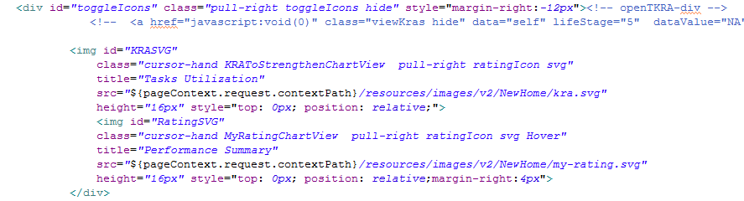

* To show toggle icons in chart panel for supervisor home page.

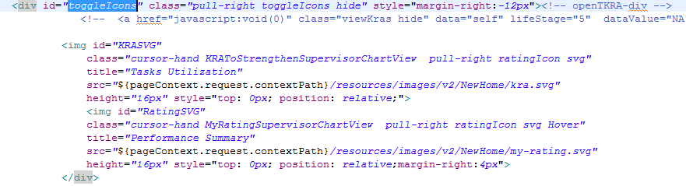

## **File Path**

"/upraizal-web/src/main/webapp/WEB-INF/pages/newHome1.jsp"

## **Purpose**

* Code to switch between two charts and show and hide respective chart titles and highlight respective toggle icon.

## **Modifications**

* Function to switch between two charts by calling respective function to populate chart.

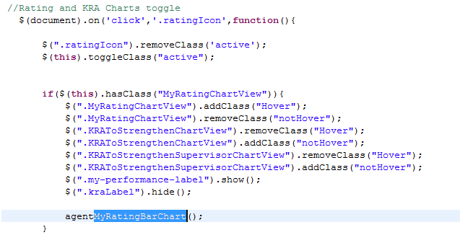

## **File Path**

"/upraizal-web/src/main/webapp/resources/js/v2/customScripts/home-agent.js"

## **Purpose**

* Created function to populate KRA’s strengthen chart for agent.

## **Modifications**

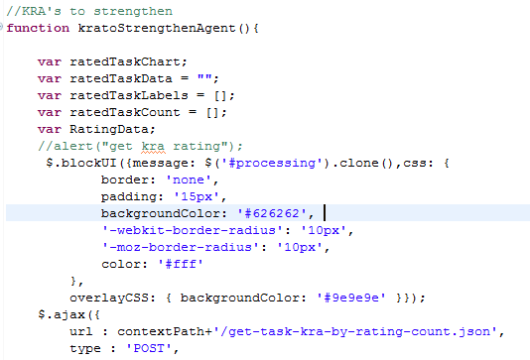

## **File Path**

"/upraizal-web/src/main/webapp/resources/js/v2/customScripts/home-supervisor.js"

## **Purpose**

* Created function to populate KRA’s strengthen chart for supervisor.

## **Modifications**

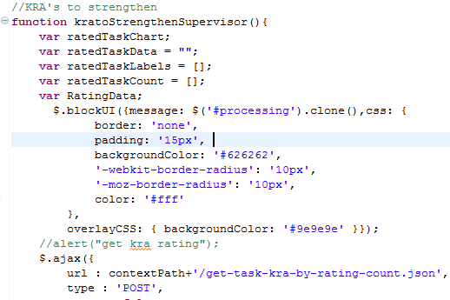

## **File Path**

"/upraizal-web/src/main/webapp/resources/css/v2/common/style.css"

## **Purpose**

* Added styles related to toggle icons.

## **Modifications**

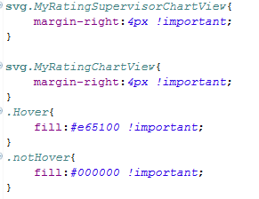

## **File Path**

"/upraizal-web/src/main/webapp/WEB-INF/pages/newHome.jsp"

## **Purpose**

* Added toggle icons for chart panel for both modeler and supervisor.

## **Modifications**

* To show toggle icons in chart panel for agent/modeler home page.



* To show toggle icons in chart panel for supervisor home page.



## **File Path**

“/upraizal-task/src/main/java/com/defteam/task/controller/KRAController.java"

## **Purpose**

* Written a service call for get the KRA’s based data .

## **Modifications**

* Service call to get the required data

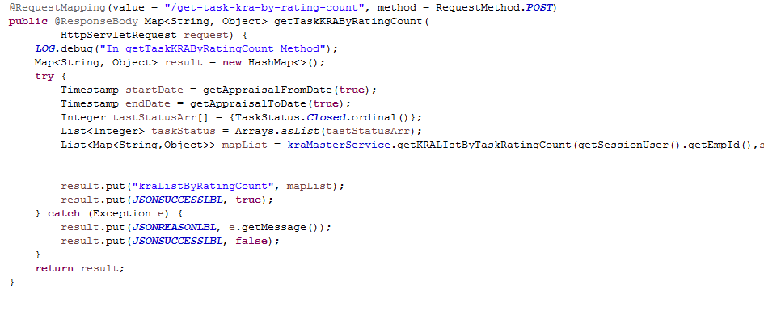

## **File Path**

“/upraizal-task/src/main/java/com/defteam/task/bpo/KraMasterBPOImpl.java"

## **Purpose**

* Written a logic to find KRA’s, Which Employee needs to strengthen.

## **Modifications**

* Business logic to get the KRA’s based on the benchmark criteria.

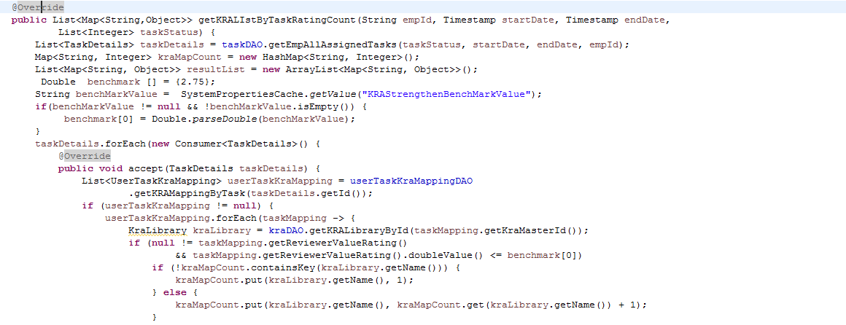

<--------------------------------Continuation of logic here-------------------------------->

## **File Path**

“/upraizal-task/src/main/java/com/defteam/task/dao/TaskDAOImpl.java"

## **Purpose**

* Written a data base query to find KRA’s, Which Employee needs to strengthen.

## **Modifications**

* Data base query to find out the data based on given parameters.

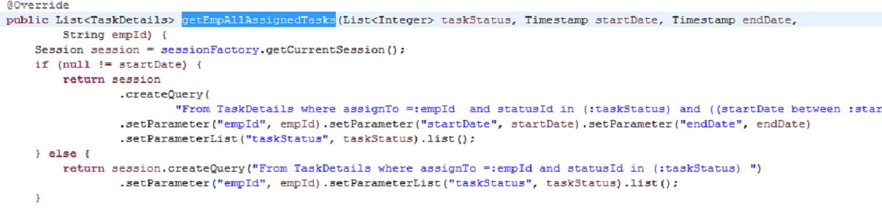

<--------------------------------Continuation of logic here-------------------------------->

.

# List of required Jars & File Paths

* /upraizal-web/src/main/webapp/WEB-INF/pages/newHome.jsp
* /upraizal-web/src/main/webapp/WEB-INF/pages/newHome1.jsp
* /upraizal-web/src/main/webapp/resources/js/v2/customScripts/home-agent.js
* /upraizal-web/src/main/webapp/resources/js/v2/customScripts/home-supervisor.js
* /upraizal-web/src/main/webapp/resources/css/v2/common/style.css
* /upraizal-task/src/main/java/com/defteam/task/controller/KRAController.java
* /upraizal-task/src/main/java/com/defteam/task/service/KraMasterService.java
* /upraizal-task/src/main/java/com/defteam/task/service/KraMasterServiceImpl.java
* /upraizal-task/src/main/java/com/defteam/task/bpo/KraMasterBPO.java
* /upraizal-task/src/main/java/com/defteam/task/bpo/KraMasterBPOImpl.java
* /upraizal-task/src/main/java/com/defteam/task/dao/TaskDAO.java
* /upraizal-task/src/main/java/com/defteam/task/dao/TaskDAOImpl.java

# Use cases (Must for Unit Test)

* If both the charts have data, then only toggle icons will appear in panel.
* Currently shown chart toggle icon is highlighted in orange color and the other icon will be in black color.
* KRA’s to strengthen bars should be in descending order in chart.
* KRA’s to strengthen benchmark set is configurable, If any rating scale changes in the future then this bench mark set also be changed accordingly.
* This feature is applicable only for closed tasks in the system.

Home Page Screens:

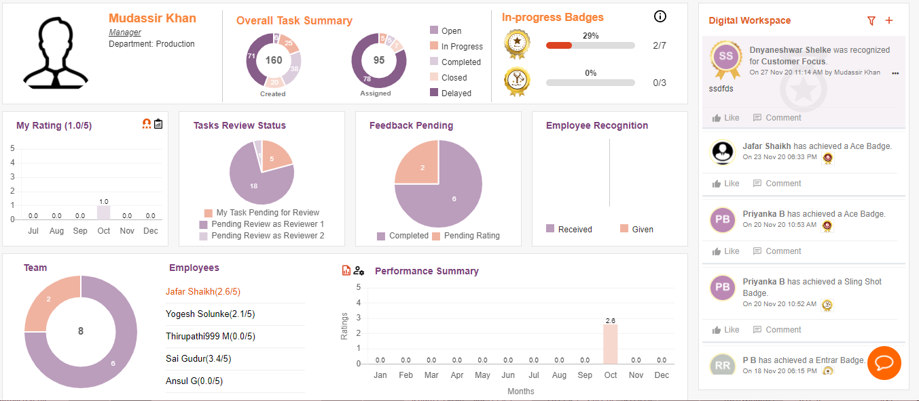

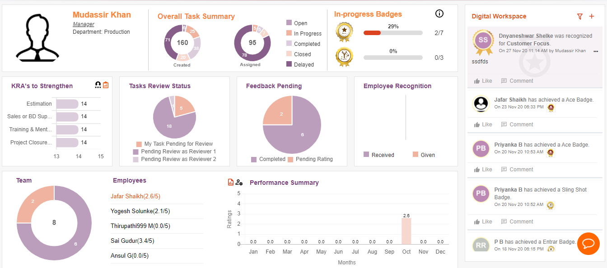



Configuration Page Screens:

